LAPORAN POSTTEST 5 PRAKTIKUM PEMROGRAMAN VISUAL

LINK VIDEO : <https://youtu.be/0cchF6bV8wg>

Screenshot Tabel Database Yang Digunakan :

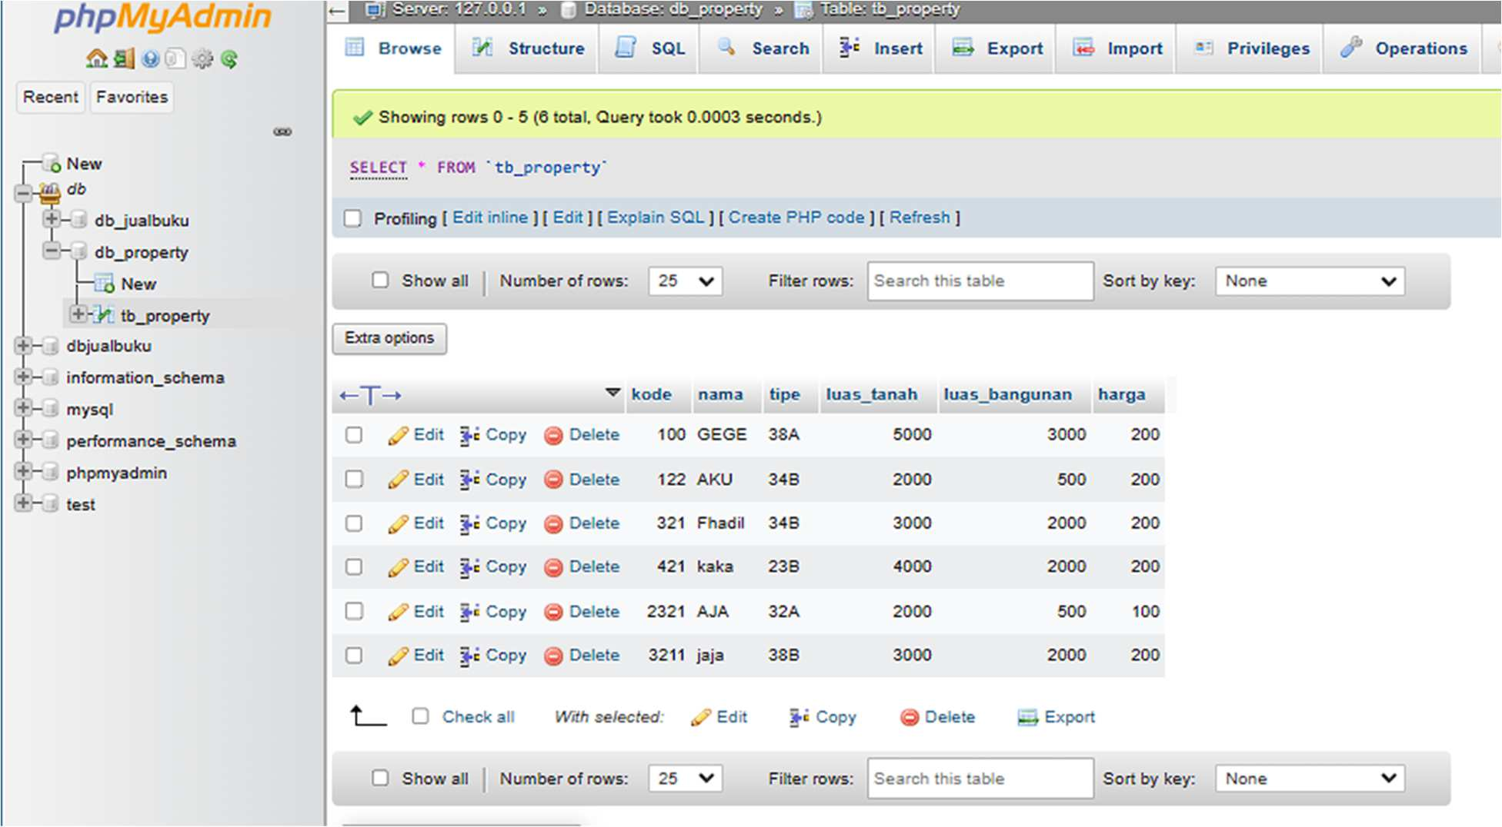

SOURCE CODE

* Module1.vb

Imports System.Data.SqlClient Module Module1

Public CONN As MySqlConnection Public CMD As MySqlCommand Public RD As MySqlDataReader Public DA As MySqlDataAdapter Public DS As DataSet

Public STR As String

Sub koneksi()

Try

Dim STR As String = "server=localhost;userid=root;password=;database=db_property"

CONN = New MySqlConnection(STR)

If CONN.State = ConnectionState.Closed Then CONN.Open()

End If

Catch ex As Exception MessageBox.Show(ex.Message)

End Try End Sub

End Module

* Form1.vb

Imports System.Windows

Imports System.Windows.Forms.DataFormats

Public Class Form1

Dim tutup As String

Private Sub Button1_Click(sender As Object, e As EventArgs) Handles Button1.Click

Form2.Show() Me.Hide()

End Sub

Private Sub Button3_Click(sender As Object, e As EventArgs) Handles Button3.Click

tutup = MessageBox.Show("Apakah Anda Ingin Menutup Program ?", "Exit", MessageBoxButtons.YesNo, MessageBoxIcon.Question)

If tutup = MsgBoxResult.Yes Then End

Else End If

End Sub

End Class

# Form2.vb

Imports System.Data.SqlClient

Imports System.Windows.Forms.VisualStyles.VisualStyleElement

Public Class Form2 Sub Kosong()

Kode.Clear() txtNama.Clear() txtTipe.Clear() txtLuasTanah.Clear() txtLuasBangunan.Clear() txtHarga.Clear() Kode.Focus()

End Sub

Private Sub Data_Load(sender As Object, e As EventArgs) Handles MyBase.Load Call koneksi()

Call Kosong() End Sub

Private Sub btnSimpan_Click(sender As Object, e As EventArgs) Handles btnSimpan.Click

If Kode.Text = "" Or txtNama.Text = "" Or txtTipe.Text = "" Or txtLuasTanah.Text = "" Or txtLuasBangunan.Text = "" Or txtHarga.Text = "" Then

MsgBox("Data Belum Lengkap") Kode.Focus()

Exit Sub Else

CMD = New MySqlCommand("Select * From tb_property where kode='" & Kode.Text & "'", CONN)

RD = CMD.ExecuteReader RD.Read()

RD.Close()

If Not RD.HasRows Then

Dim Simpan As String = "insert into tb_property(kode,nama,tipe,luas_tanah,luas_bangunan,harga)values('

" & Kode.Text & "','" & txtNama.Text & "','" & txtTipe.Text & "','" & txtLuasTanah.Text & "','" & txtLuasBangunan.Text & "','" & txtHarga.Text & "')"

CMD = New MySqlCommand(Simpan, CONN) CMD.ExecuteNonQuery()

MsgBox("Simpan Data Sukses.....", MsgBoxStyle.Information,

"Perhatian")

End If

Call Kosong() Kode.Focus()

End If End Sub

Private Sub Button1_Click(sender As Object, e As EventArgs) Handles Button1.Click

Form3.Show() Me.Hide()

End Sub

Private Sub back_Click(sender As Object, e As EventArgs) Handles back.Click

Form1.Show() Me.Hide()

End Sub

Private Sub btnBatal_Click(sender As Object, e As EventArgs) Handles btnBatal.Click

Kode.Text = "" txtNama.Text = "" txtTipe.Text = "" txtLuasTanah.Text = "" txtLuasBangunan.Text = "" txtHarga.Text = ""

End Sub

End Class

# Form3.vb

Imports System.Reflection.Emit

Imports System.Windows.Forms.VisualStyles.VisualStyleElement.Tab

Public Class Form3

    Sub AturGrid()

        If DataGridView1.RowCount > 0 Then

            DataGridView1.Columns(0).Width = 60

            DataGridView1.Columns(1).Width = 200

            DataGridView1.Columns(2).Width = 100

            DataGridView1.Columns(3).Width = 150

            DataGridView1.Columns(4).Width = 150

            DataGridView1.Columns(5).Width = 200

            DataGridView1.Columns(0).HeaderText = "KODE"

            DataGridView1.Columns(1).HeaderText = "NAMA PEMILIK"

            DataGridView1.Columns(2).HeaderText = "TIPE BANGUNAN"

            DataGridView1.Columns(3).HeaderText = "LUAS TANAH"

            DataGridView1.Columns(4).HeaderText = "LUAS BANGUNAN"

            DataGridView1.Columns(5).HeaderText = "HARGA PROPERTY"

        End If

    End Sub

    Sub Tampil()

        DA = New MySqlDataAdapter("Select * From tb_property", CONN)

        DS = New DataSet

        DS.Clear()

        DA.Fill(DS, "tb_property")

        DataGridView1.DataSource = DS.Tables("tb_property")

        DataGridView1.Refresh()

    End Sub

    Private Sub Data_Load(sender As Object, e As EventArgs) Handles MyBase.Load

        Call koneksi()

        Call Tampil()

        Call AturGrid()

    End Sub

    Private Sub Button1_Click(sender As Object, e As EventArgs) Handles Button1.Click

        Form2.Show()

        Me.Hide()

    End Sub

    Private Sub back_Click(sender As Object, e As EventArgs) Handles back.Click

        Form1.Show()

        Me.Hide()

    End Sub

    Private Sub btnDel_Click(sender As Object, e As EventArgs) Handles btnDel.Click

        If DataGridView1.CurrentRow.Index <> DataGridView1.NewRowIndex Then

            CMD = New MySqlCommand("Delete from tb_property where kode = '" & TextBox1.Text & "'", CONN)

            CMD.ExecuteNonQuery()

            DataGridView1.Rows.RemoveAt(DataGridView1.CurrentRow.Index)

        End If

    End Sub

    Private Sub btnUpdate_Click(sender As Object, e As EventArgs) Handles btnUpdate.Click

        If DataGridView1.CurrentRow.Index <> DataGridView1.NewRowIndex Then

            Form4.Show()

            Me.Hide()

        End If

    End Sub

    Private Sub txtCari_KeyPress(sender As Object, e As KeyPressEventArgs) Handles txtCari.KeyPress

        If e.KeyChar = Chr(13) Then

            CMD = New MySqlCommand("Select * from tb_property where kode like '%" & txtCari.Text & "%'", CONN)

            RD = CMD.ExecuteReader

            RD.Read()

            If RD.HasRows Then

                RD.Close()

                DA = New MySqlDataAdapter("Select * from tb_property where kode like '%" & txtCari.Text & "%'", CONN)

                DS = New DataSet

                DA.Fill(DS, "Dapat")

                DataGridView1.DataSource = DS.Tables("Dapat")

                DataGridView1.ReadOnly = True

            Else

                RD.Close()

                MsgBox("Data Tidak Ditemukan")

            End If

        End If

    End Sub

    Private Sub DataGridView1_CellContentClick(sender As Object, e As DataGridViewCellEventArgs) Handles DataGridView1.CellContentClick

        Dim i As Integer

        i = Me.DataGridView1.CurrentRow.Index

        With DataGridView1.Rows.Item(i)

            Me.TextBox1.Text = .Cells(0).Value

        End With

    End Sub

End Class

* Form4.vb

Public Class Form4

    Sub AturGrid()

        If DataGridView1.RowCount > 0 Then

            DataGridView1.Columns(0).Width = 60

            DataGridView1.Columns(1).Width = 200

            DataGridView1.Columns(2).Width = 100

            DataGridView1.Columns(3).Width = 150

            DataGridView1.Columns(4).Width = 150

            DataGridView1.Columns(5).Width = 200

            DataGridView1.Columns(0).HeaderText = "KODE"

            DataGridView1.Columns(1).HeaderText = "NAMA PEMILIK"

            DataGridView1.Columns(2).HeaderText = "TIPE BANGUNAN"

            DataGridView1.Columns(3).HeaderText = "LUAS TANAH"

            DataGridView1.Columns(4).HeaderText = "LUAS BANGUNAN"

            DataGridView1.Columns(5).HeaderText = "HARGA PROPERTY"

        End If

    End Sub

    Sub Tampil()

        DA = New MySqlDataAdapter("Select * From tb_property", CONN)

        DS = New DataSet

        DS.Clear()

        DA.Fill(DS, "tb_property")

        DataGridView1.DataSource = DS.Tables("tb_property")

        DataGridView1.Refresh()

    End Sub

    Private Sub btnBatal_Click(sender As Object, e As EventArgs) Handles btnBatal.Click

        Form3.Show()

        Me.Hide()

    End Sub

    Private Sub btnEdit_Click(sender As Object, e As EventArgs) Handles btnEdit.Click

        If txtUbahKode.Text = "" Then

            MsgBox("Kode Belum Diisi")

            txtUbahKode.Focus()

        Else

            Dim Ubah As String = "Update tb_property set kode = '" & txtUbahKode.Text & "',

                                    nama = '" & txtUbahNama.Text & "',

                                    tipe = '" & txtUbahTipe.Text & "',

                                    luas_tanah = '" & txtUbahLuasTanah.Text & "',

                                    luas_bangunan = '" & txtUbahLuasBangunan.Text & "',

                                    harga = '" & txtUbahHarga.Text & "'

                                    where kode = '" & txtUbahKode.Text & "'"

            CMD = New MySqlCommand(Ubah, CONN)

            CMD.ExecuteNonQuery()

            MessageBox.Show("Data sudah diubah", "Informasi", MessageBoxButtons.OK, MessageBoxIcon.Information)

            Tampil()

            txtUbahKode.Focus()

        End If

    End Sub

    Private Sub Form4_Load(sender As Object, e As EventArgs) Handles MyBase.Load

        Call koneksi()

        Call Tampil()

        Call AturGrid()

    End Sub

    Private Sub DataGridView1_CellContentClick(sender As Object, e As DataGridViewCellEventArgs) Handles DataGridView1.CellContentClick

        Dim i As Integer

        i = Me.DataGridView1.CurrentRow.Index

        With DataGridView1.Rows.Item(i)

            Me.txtUbahKode.Text = .Cells(0).Value

        End With

    End Sub

    Private Sub back_Click(sender As Object, e As EventArgs) Handles back.Click

        Form1.Show()

        Me.Hide()

    End Sub

End Class